Appendix 1: Assignment submission cover sheet ASSIGNMENT
SUBMISSION COVER SHEET
Student Id: cse25-204
Student names: Sharon Masala
Student email: cse25-204@thuto.bac.ac.bw
Cohort: 2026
Assignment title: SCIS WMD_2026 A01
Date of submission: 20/03/2026
Programme of Study: Computer Systems Engineering
Year of Study: YEAR 1
Intellectual property statement
By checking the box below, I certify that this assignment is my own work and is free from plagiarism. I understand that the assignment may be checked for plagiarism by electronic or other means and may be transferred and stored in a database for the purposes of data-matching to help detect plagiarism. The assignment has not previously been submitted for assessment in any other unit or to any other institution. I have read and understood the Botswana Accountancy College plagiarism guidelines policy.
☐ Agree
Signature……………………………………. Date………20/03/2026………………………………….

WEBSITE PLANNING AND DOCUMENTATION

Website Specifications

The Art of Interior Design

Website Objective
The Art of Interior Design is a professional interior design company based in Gaborone, Botswana. The primary objective of this website is to provide online services, residential design, commercial design and space planning furniture styling. The main objective of this website is to help the company get more clients by showing their work online and making it easy for people to contact them as of today people search for services on the internet before they decide to hire someone.

TRANSFORMING INDOOR SPACES THROUGH CREATIVITY, ART AND DESIGN

The website aims to achieve the following business goals:
- To provide step by step interior design guides.
- To show the company’s past projects through a portfolio so the potential clients can see the quality of their work.
- To educate users about interior designs by providing tips for DIY decorators or DIY lovers
- Generate new client enquiries through a consultation booking form that allows potential clients to describe their project and request a free, no obligation consultation.

Target Audience
Primary Audience
- Homeowners and renters
- Age: 27-65 years old
- Gender: All genders
- Income level: Middle to upper-middle households investing in quality, aesthetic home design.
- Technical Aptitude: Moderate- comfortable browsing on smartphones and desktop computers using social media and research services online.

- Behavior: They search online interior design services, design inspiration. They value aesthetics and portfolio evidence before reaching out.

Secondary Audience

  - Business owners
  - Property managers
  - Age: 30-55
  - Technical Aptitude: High regular users who conduct research and procurement online.
  - Behavior: Restaurant owners, retail operators looking for reliable interior partner. They value portfolio evidence and clear communication.

Type of Website
- The Art of Interior Designs will be an informative and interactive website designed to market the company’s interior design services, display a portfolio of completed projects.
- The website is designed to be simple, visually appealing and easy to navigate for all users.

Key characteristics of this website include:
- It has a gallery to show completed projects.
- It has pages that explain the company’s services in detail.
- It has a contact and feedback page with a form.
- The design of the website itself must look good because it represents a design company.
- Portfolio driven content highlighting the quality and range of completed design projects.
- Mobile responsive design to cater to users browsing on smartphones, laptops and tablets.

Information Design and Taxonomy
- The website follows a flat hierarchy.
- The 3-click rule is maintained.
- The website consists of 6 pages which is the index, about us, contact us, services and gallery.

Storyboard Flowchart
The website structure begins with the Home page which serves as the central navigation hub, after the home page users can access other pages which are (About, Services, Gallery, Blog and contact). The service page is then divided into interior and home staging services which will allow users to explore more offerings. The gallery page shows the before and after projects and other designs.

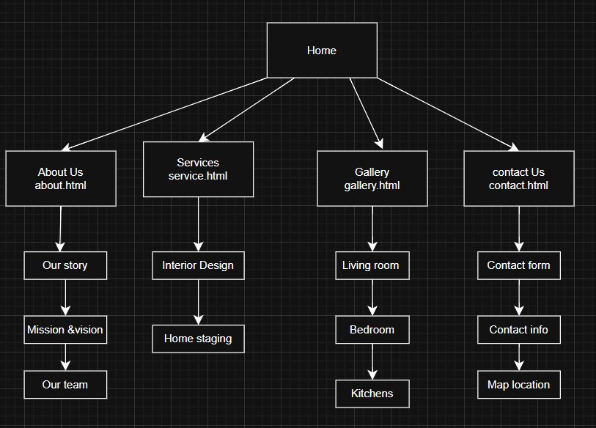

Site Map

The site map below shows all the pages of the website and how they are connected to each other. The website has 5 main pages. All 5 pages are connected through a navigation bar that is at the top of every page. This means that no matter which page a user is on, they can always go to any other page with just one click. Below are some examples of how a user would navigate the site:
- Home page to About Us page: 1 click
- Home page to Services page: 1 click
- Home page to Gallery page: 1 click
- Home page to Contact Us page: 1 click
- About Us page to Contact Us page: 1 click (through the navigation bar)
- Services page to Contact Us page: 1 click (through the CTA button or navigation bar)

Home (index.html)-This is the first page visitors see. It has a big banner at the top with a button to book a consultation. Below there are the services, a section about the company, some project photos and client reviews
About Us (about.html)-This page tells visitors about the company. It has the company's story, the mission and vision, the team members and the values of the company.
Gallery (gallery.html)-This is the portfolio page. It shows photos of completed projects. Visitors can filter the photos by category and click on any photo to see it bigger using a lightbox.
Contact Us (contact.html)-This is the feedback and contact page. It has a form where visitors fill in their name, email, phone number, the service they need and a description of their project. It also has the company's address and a map.
Services (services.html)- This page explains all the services in detail. The services include residential design, commercial design, space planning, furniture styling and color consultation.

Site Map
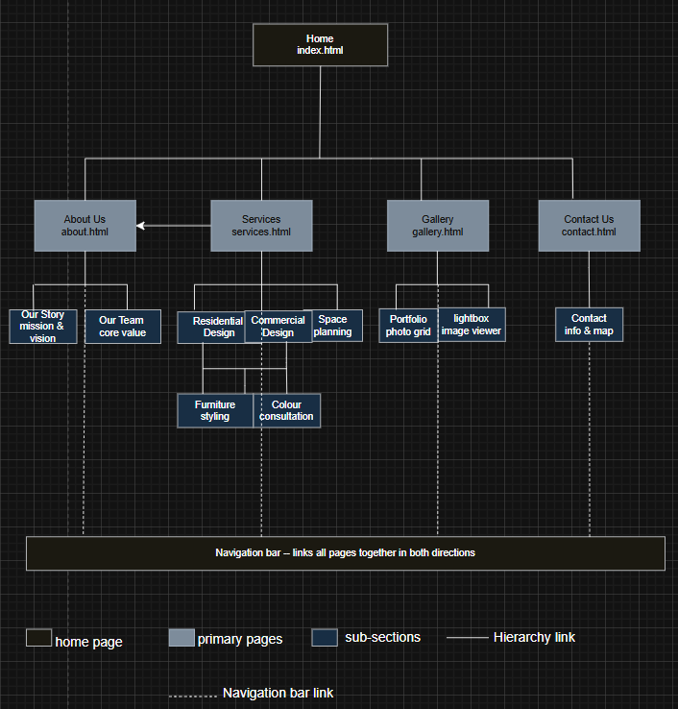

Technical Brief

This section lists all the tools and technologies I used to build the website. I choose these tools based on what we have been learning in the module and because they are suitable for a website of this size and type
Technologies used

Technology / Tool | What I used it for
HTML5 | I used HTML5 to build the structure of all 5 pages. I used semantic elements like <header>, <nav>, <main>, <section>, <article> and <footer> to make the code clean and meaningful. I also used HTML5 form elements with required attributes for the contact form validation.
CSS3 | I wrote one external CSS file called style.css that controls the look of the entire website. I used CSS variables to manage colours, CSS Grid and Flexbox for layouts, and media queries to make the site responsive on different screen sizes.
Bootstrap 5 | I used Bootstrap 5 to help with the responsive grid system and for some components like buttons and the navigation bar
VS Code | I used Visual Studio Code as my code editor. I used the Live Server extension to preview the website while I was building it.
Git and GitHub | I used Git to track my changes and GitHub to store my code. I also published the website using GitHub Pages.
GIMP | I used GIMP to edit and resize images for the website. I also used it to create the company logo.

